
St Brendan’s College

Teacher and Student Details
Student name: | Year Level: 8
Teacher name: Mr Schellein | Date: 20/03/2025

Subject | Digital Technology
Technique | Examination — Short Response
Unit | Microcomputers | Instrument Number: 1
Topics | Networks and Algorithms
Conditions | - Individual – closed book, exam conditions  - 60 minutes

Australian Curriculum
Trace algorithms to predict output for a given input and to identify errors (AC9TDI8P06)
investigate how data is transmitted and secured in wired and wireless networks including the internet (AC9TDI8K02)

Criteria | Marks Attained | Grade
- Knowledge and Understanding
- Process and Production Skills
Overall Result (A – E)

Feedback

Stimulus: eSports Tournament
Jonathan is setting up a pinball esports tournament. He wants to display game telemetry in real time on big televisions for the audience to see.

He isn’t sure if he should use a wired or wireless network to transfer the data.

TASK 1: Write a paragraph explaining the differences between wired and wireless networks in detail. / 4 marks
_______________________________________________________________________________________________________________________________________________________________________________________________________________________________________________________________________________________________________________________________________________________________________________________

TASK 2: Write a paragraph recommending wired or wireless networks for this case and why. / 2 marks
__________________________________________________________________________________________________________________________________________________________________________________________________________________________________________________________________________________________________________________________________________________________________________________________________________________________________________________________________

Stimulus: Music Festival
Sarah is organizing an outdoor music festival with multiple stages, food vendors, and merchandise stalls. She needs a network to support digital ticket scanning, mobile payments, and live streaming from different areas of the festival grounds by festival staff to their twitch channel during shows.

TASK 3: Write a paragraph recommending wired or wireless networks for this case and why. Ensure that you address all the potential needs of the user. / 4 marks
________________________________________________________________________________________________________________________________________________________________________________________________________________________________________________________________________________________________________________________________________________________________________________________________________________________________________________________________________________________________________________________________________________________________________________________________________________________

Stimulus: Diagram depicting a mobile network set up on a mountain range

TASK 4: The passengers in one of these cars can upload a video to TikTok, which one? Why is it able to? Why can’t the other one? / 3 marks
__________________________________________________________________________________________________________________________________________________________________________________________________________________________________________________________________________________________________________________________________________________________________________________________________________________________________________________________________

TASK 5: What realistic changes would need to be made so that passengers in both cars could upload a video? Why would this work? / 2 marks
__________________________________________________________________________________________________________________________________________________________________________________________________________________________________________________________________________________________________________________________________________________________________________________________________________________________________________________________________
___________________________________________________________________________

Stimulus: There are two errors in the code and wiring setup below that result in the code not working. For Task 6 and 7.
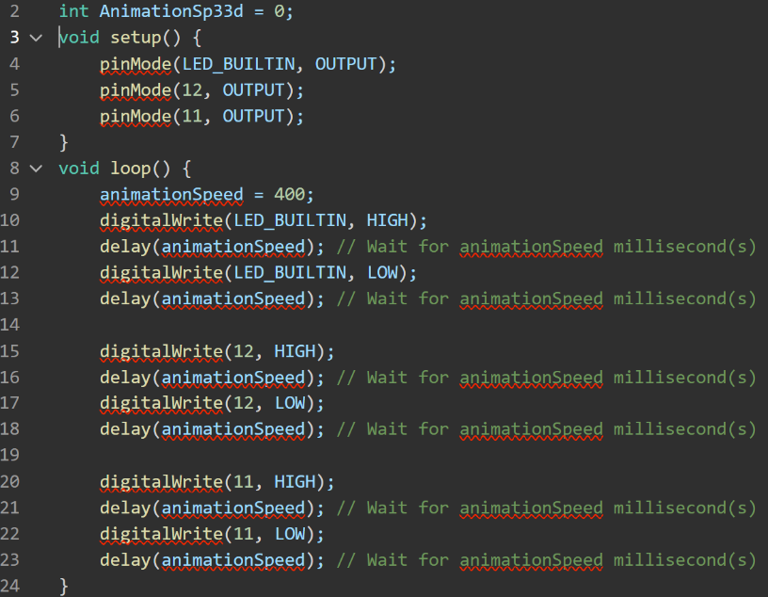
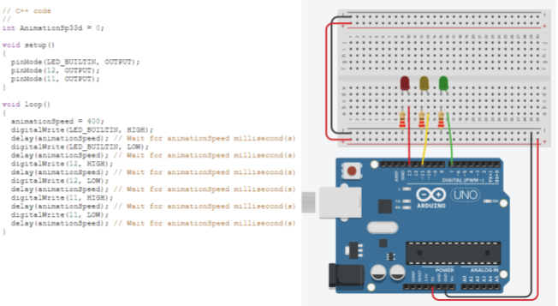
Task 6: Find the first error, explain the error, how to fix it and why that fix will fix the error. / 3 marks
_______________________________________________________________________________________________________________________________________________________________________________________________________________________________________________________________________________________________________________________________________________________________________________________

Task 7: Find the second error, explain the error, how to fix it and why that fix will fix the error. / 3 marks
_______________________________________________________________________________________________________________________________________________________________________________________________________________________________________________________________________________________________________________________________________________________________________________________

Stimulus: Code showing interaction between serial monitor and control statements for Task 8, 9 and 10
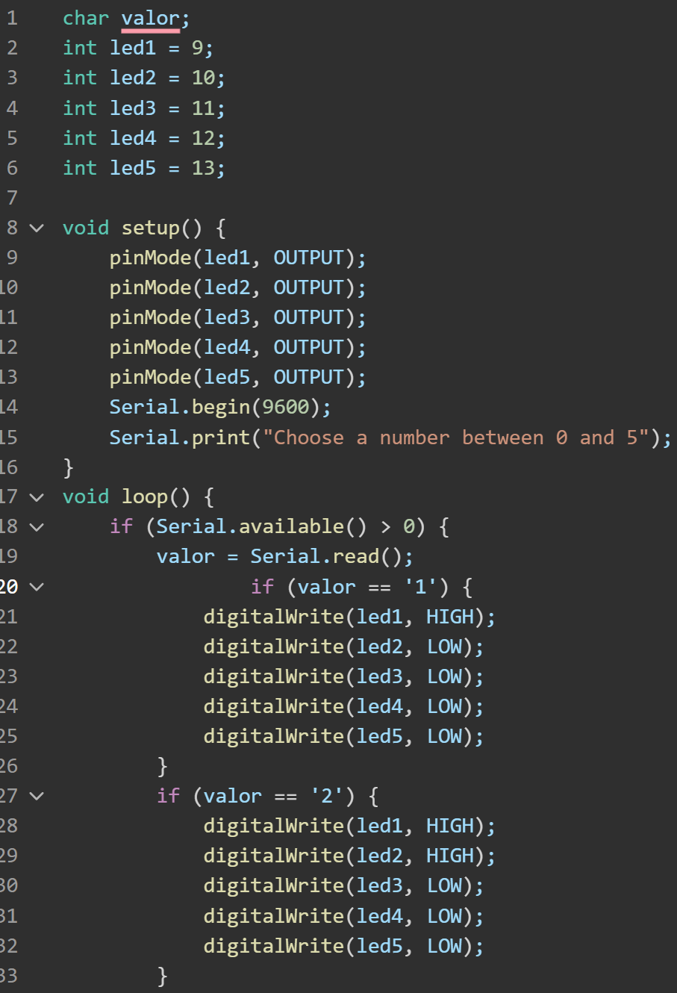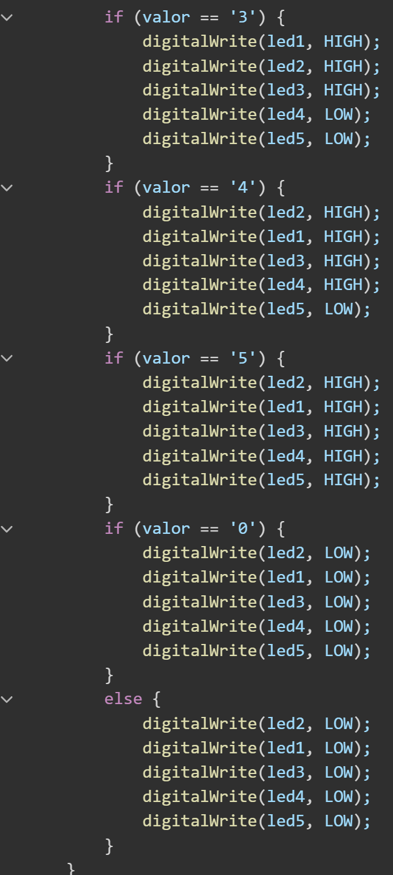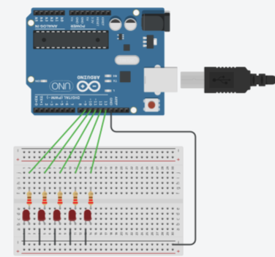
TASK 8: what will be displayed in the serial for each test case / 2 Marks
Write the correct value next to ‘Output?’ and ‘Input?’ in the table below.

Input | Output | Input | Output
0 | Output? _____ | 17 | Output? _____
Input? _____ | 4 LEDs Lit | Input? _____ | 1 LEDs Lit
2 | Output? _____ | 5 | Output? _____

TASK 9: Write the code to add another LED that continues the output pattern. / 4 Marks
_______________________________________________________________________________________________________________________________________________________________________________________________________________________________________________________________________________________________________________________________________________________________________________________
TASK 10: We want to change the program so that instead of asking for a number from the user, the program automatically cycles through the numbers itself. Write a FOR loop that will count from 0 to 5. / 1 Mark
Stimulus: Code showing the interaction between sensors and conditional statements to turn on an LED. For Task 11 and 12
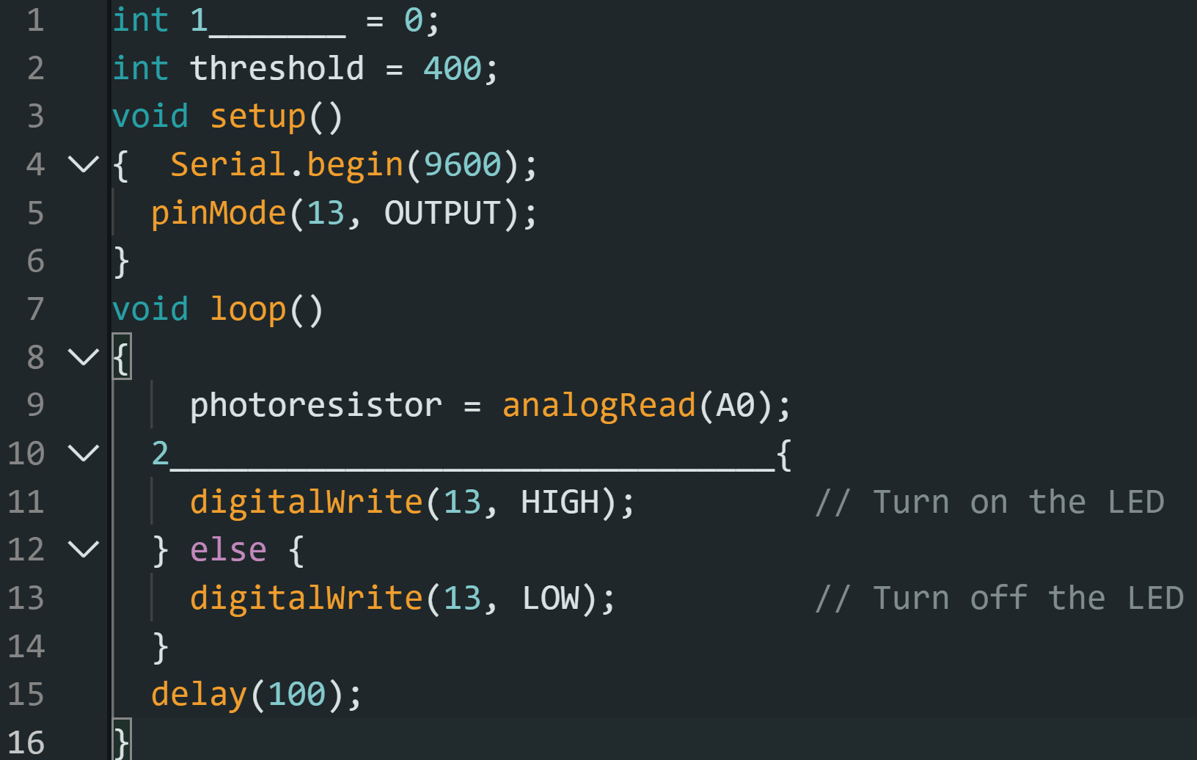
TASK 11: This code is missing the variable used to store the data from a sensor (line 1). Write the correct code. / 1 Mark
TASK 12: This code is missing the IF statement used to activate the LED (line 10). Write the correct code / 1 Mark

 |  | A |  |  | B |  |  | C |  |  | D |  |  | E
 |  | The folio of student work contains evidence of the following:
Knowledge and Understanding | Digital Systems | considered explanation of how data is transmitted and secured in networks |  |  | detailed explanation of how data is transmitted and secured in networks |  |  | explanation of how data is transmitted and secured in networks |  |  | description of how data is transmitted and/or secured in networks |  |  | statement/s about data transmission and/or security
 |  | A+  15 | A  14 | A-  13 | B+  12 | B  11 | B  10 | C+  9 | C  8 | C-  7 | D+  6 | D  5 | D-  4 | E+  3 | E  2 | E-  1
Processes and production skills | Generating and designing | proficient design and tracing of algorithms |  |  | effective design and tracing of algorithms |  |  | design and tracing of algorithms |  |  | guided design and/or tracing of algorithms |  |  | directed design and/or tracing of algorithms
 |  | A+  15 | A  14 | A-  13 | B+  12 | B  11 | B  10 | C+  9 | C  8 | C-  7 | D+  6 | D  5 | D-  4 | E+  3 | E  2 | E-  1

